Use the Internet to research and answer the following questions
- Identify the frequency range of normal human hearing.

- Describe the key properties of ultrasound.

- Identify the differences between ultrasound and sound in normal hearing range. (verbatim dot point)

- What is a piezoelectric material?

- Describe the piezoelectric effect.

- With the aid of a diagram, outline how ultrasound is produced by applying an alternating potential difference to a piezoelectric crystal.

- Use the Internet to observe at least two ultrasound images of different body organs. Identify the organs observed and describe the main characteristics of the ultrasound images that you have observed.

- Identify the frequency range of normal human hearing.
Humans can hear sounds from ~20 hertz to 20 kHz [providing their hearing is excellent and the sounds are loud enough – have sufficient energy]
- Describe the key properties of ultrasound.
Ultrasound is sound having a frequency higher than can be heard by the human ear. Ultrasound travels through media at the same speed as sound in the normal hearing range and the speed depends on the properties of the medium [specifically the density and elasticity of the medium]
[Ultrasound used for medical imaging typically has a frequency greater than two megahertz and less than 10 megahertz]
- Identify the differences between ultrasound and sound in normal hearing range. (Verbatim dot point)
Ultrasound has a frequency greater than the highest frequency that a human can hear however ultrasound used for medical imaging has frequencies between 2 MHz and 10 MHz.
- What is a piezoelectric material?
A piezoelectric material is a crystalline substance capable of producing a voltage across opposite faces of the crystal when it is deformed by a force. The process is reversible and the application of a voltage across opposite faces of the crystal causes the crystal to physically change its size slightly.
- Describe the piezoelectric effect.
The piezoelectric effect is the conversion by a crystal of mechanical energy when a force is applied that deforms the crystal into electrical energy or the production of mechanical energy when a potential difference is applied to the crystal.
- With the aid of a diagram, outline how ultrasound is produced by the application of an alternating potential difference to a piezoelectric crystal.
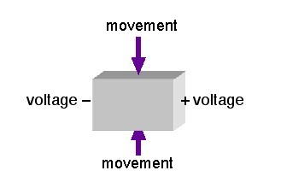When a voltage is applied to the opposite faces of a piezoelectric crystal as shown, a force is produced that causes the crystal to deform, creating movement of opposite faces of the crystal. When the voltage polarity is reversed, the movement is in the opposite direction. Application of a high-frequency alternating voltage causes vibration of the crystal at the same frequency. The energy associated with the vibrations is transmitted through any medium in contact with the crystal. If the frequency is above 20 kHz (the upper limit of human hearing) then the sound produced is called ultrasound. If the frequency exceeds 2 MHz then the resulting ultrasound is useful for medical imaging.
- Use the Internet to observe at least two ultrasound images of different body organs. Identify the organs observed and describe the main characteristics of the ultrasound images that you have observed.
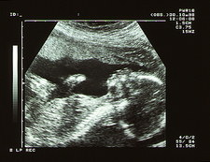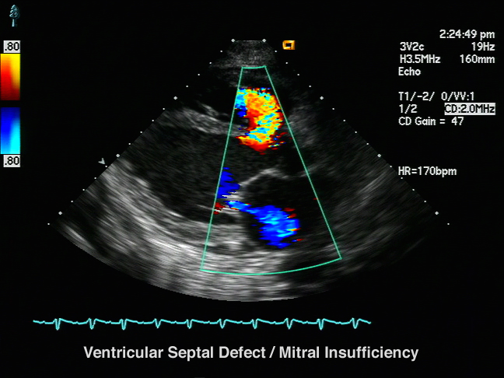
The image on the left is a foetus. Its skull can be clearly seen on the right. Its abdomen and arms are also visible.
The image on the right is a Doppler ultrasound image of the heart (organ) showing blood flow through the heart valves, which in this case are diseased.
Ultrasound images show poor resolution compared to MRI, X-rays or CAT scans. Like these imaging technologies the images produced are structural (anatomical as opposed to physiological – functional). The higher the frequency of ultrasound, the better the resolution – however there is a decrease in the ability of ultrasound to penetrate and reflect from tissues as the frequency becomes very high.
Ultrasound can be used to produce images of soft tissues and it is non-ionising and is therefore safer than X-rays or PET (which both ionise atoms and molecules).

